Real Estate Analytics Dashboard Report

1. Overview
This dashboard presents a comprehensive analysis of real estate performance across multiple Indian cities and localities. It highlights key metrics such as total sales amount, property distribution, profit trends, and furnishing status, enabling data-driven decision-making for stakeholders.

2. Key Insights

2.1 Sales Performance by City
- Cities such as Bangalore, Hyderabad, and Mumbai show consistently strong sales figures.
- Delhi and Pune demonstrate moderate performance, while Chennai and Ahmedabad show comparatively lower totals.
- The variation suggests higher demand and investment activity in metro and IT-driven cities.

2.2 Locality-Level Analysis
- Among localities, Andheri and Banjara Hills emerge as top contributors to total sales.
- Areas like Whitefield and Dwarka show moderate activity.
- Premium localities tend to generate higher transaction volumes, indicating stronger buyer interest.

2.3 Property Type Distribution
- Apartments dominate the market share, forming the largest portion of total properties.
- Independent houses and villas contribute moderately.
- Studios and penthouses represent niche segments with smaller shares.
- This indicates a strong preference for affordable and mid-range housing options.

2.4 Furnishing Status Trends
- Semi-furnished properties have the highest count, followed by furnished units.
- Unfurnished properties are least preferred.
- Buyers appear to favor ready-to-move or partially equipped homes.

2.5 Monthly Sales Trends
- Sales values remain relatively stable from January to August, with minor fluctuations.
- A noticeable dip occurs in October and November, followed by a slight recovery in December.
- This pattern may reflect seasonal slowdowns or market corrections.

2.6 Profit and Sales Relationship
- Profit trends closely follow sales patterns, indicating consistent margins.
- Cities with higher sales volumes also contribute significantly to total profit.
- This suggests efficient pricing and cost management strategies.

2.7 Property Type Contribution by City
- Apartments contribute the largest share of sales across all cities.
- Villas and independent houses show stronger presence in high-income markets like Mumbai and Bangalore.
- Studios and penthouses remain limited but may offer high-margin opportunities.

3.Interactive Filters
The dashboard includes filters for:
- Locality
- City
- Property Type
- Time (Monthly view for 2024)
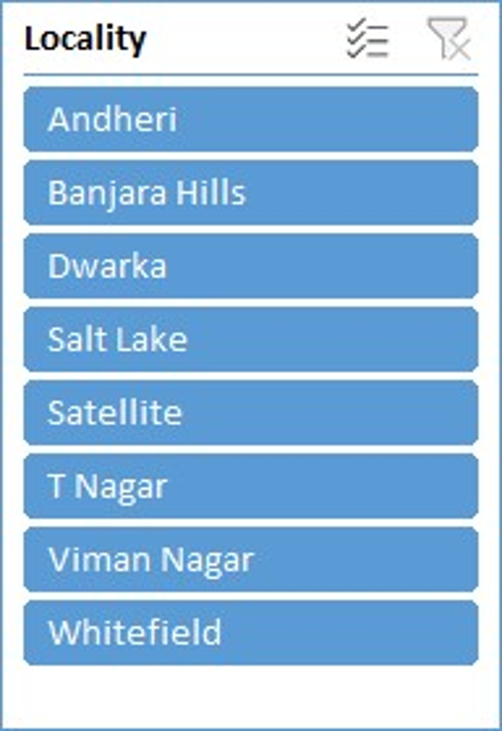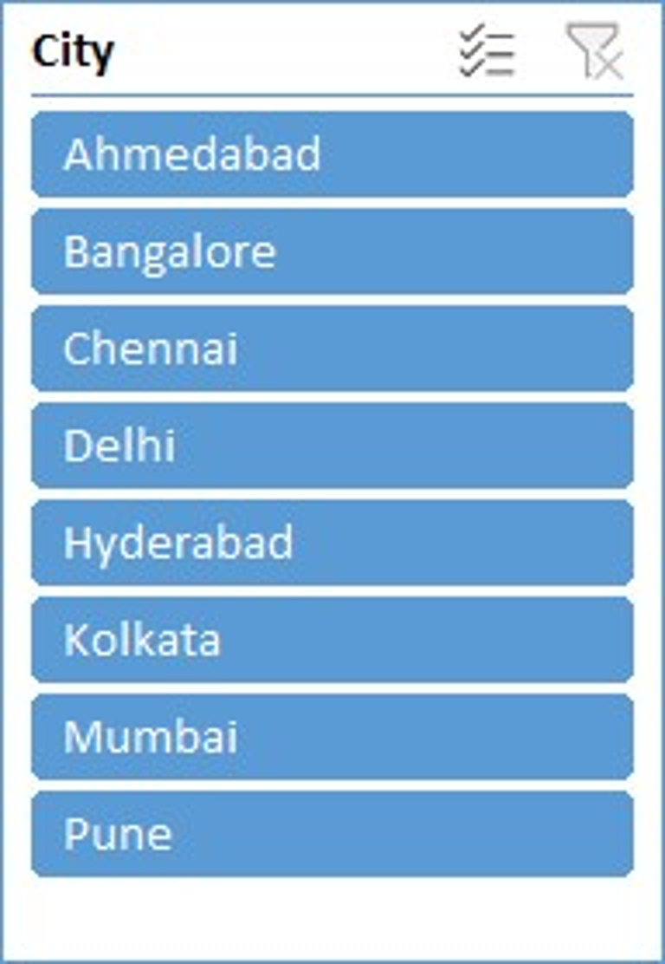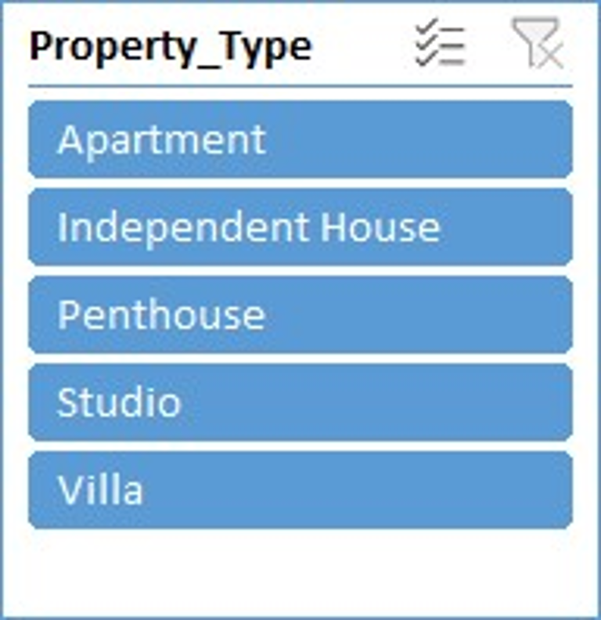
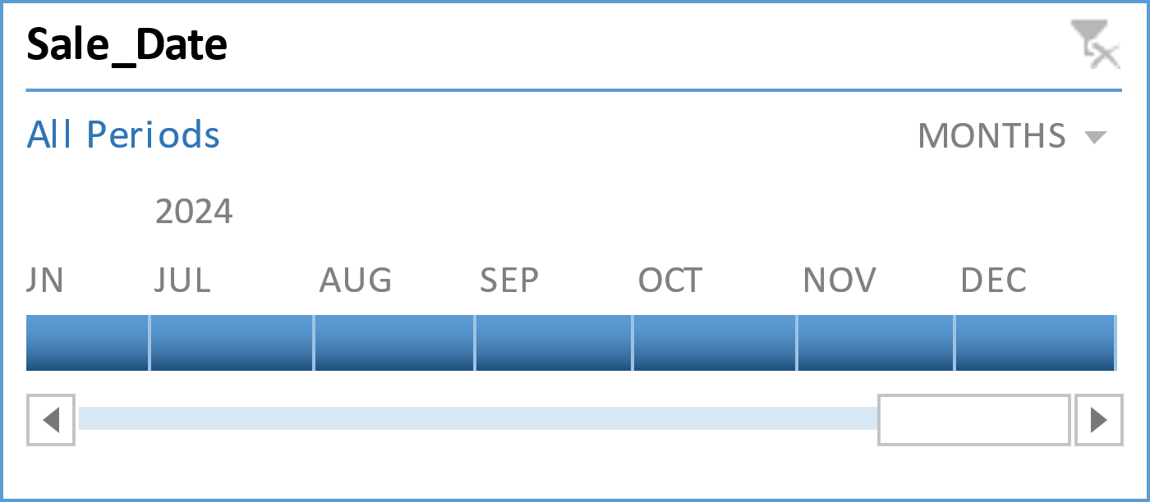

4. Dashboard

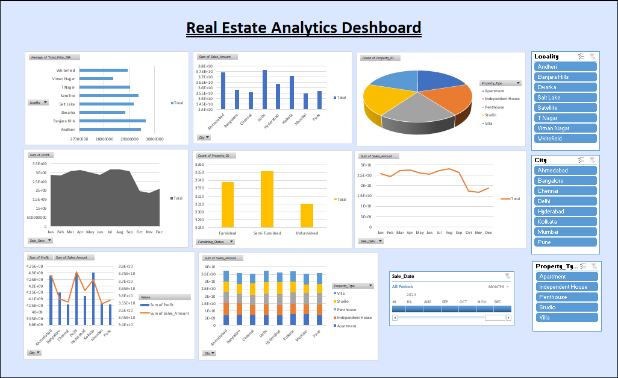

5. Conclusion
The analysis highlights:
- Strong demand in metro cities
- Dominance of apartments in the housing market
- Preference for semi-furnished properties
- Seasonal variations in sales performance
- Stable relationship between sales and profit

